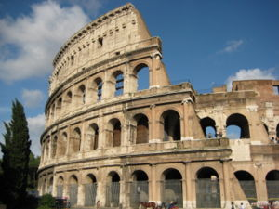
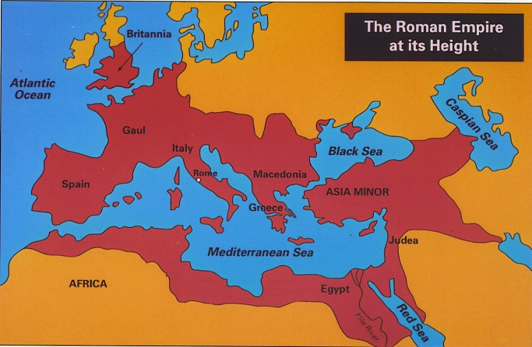
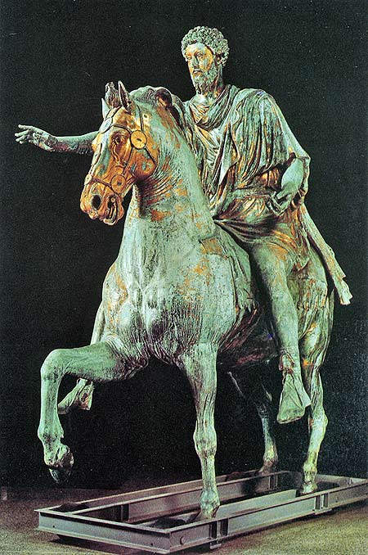
Fact Tracker

Ancient Rome
What:
___________________________________________________________________________________________________________________________________________________________________________________________________________________________________________________________________________________________________________________________________________________________________________________________________________________________________________________________________________________________________________________________________________________________________________________________________________________________________________________________________________________________________________________________________________________________________________________________________________________________________________________________________________________________________________________________________________________________________________________________________________________________________________________________________________________________________________________________________________________________________________________________________________________________________________________________________________________________________________________________________________________________________________________________________________________________________________________________________________________________________________________________________________________________________________________________________________________________________________________________________________________________________________________________________________________________________________________________________________________________________________________________________________________________________________________________________________________________________
The book says the ancient Romans were master builders. What reasons did the author to support that point? Pg.26
The author said Rome is called the Eternal city. Explain why it is called the Eternal city. Use evidence from the text to support your answer.
Where:
When:
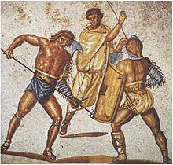
__________________________________________________________________________________________________________________________________________________________________________________________________________________________________________________________________________________________________________________________________________________________________________________________________________________________________________
Would you want to be a gladiator? Support your answer with evidence from the text.
Pantheon
The Colosseum
Aqueducts
Give a short description of the following places and things.
________________________________________________________________________________________________________________________________________________________________________________________________________________________________________________________________________________________________________________________________________________________________________________________________________________________________________

Create a drawing to show what happen to Pompeii. Pg. 77
Do you think the Ancient Romans were fair to the citizens of the lands they conquered? Explain with evidence from the text. Pg. 55
__________________________________________________________________________________________________________________________________________________________________________________________________________________________________________________________________________________________________________________________________________________________________________________________________________________________________________
Archaeologists have spent lots of time and money excavating Pompeii. Do you feel that it is important to restore Pompeii? Why?
________________________________________________________________________________________________________________________________________________________________________________________________________________________________________________________________________________________________________________________________________________________________________________________________________________________________________________________________________________________________________
How did the Ancient Romans influence other societies?

